**Lab 03**

**INTRODUCTION TO XILINX ISE, Spartan 6 BOARD AND**

**IMPLEMENTATION OF RIPPLE CARRY ADDER AND FULL SUBTRACTOR**



Spring 2025

CSE-308L

Digital System Design Lab

Submitted by: Naveed Ahmad

Registration No.: 22PWCSE2165

Class Section: B

Student Signature: ______________

Submitted to:

Engr. Shah Zada Fahim Jan

16 March 2025

Department of Computer Systems Engineering

University of Engineering and Technology, Peshawar

LAB TASKS:

1-Implement buffer ON the Kit and attach the snapshot.

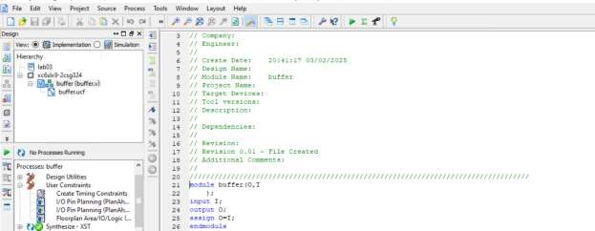

**Output on Xilinx:**

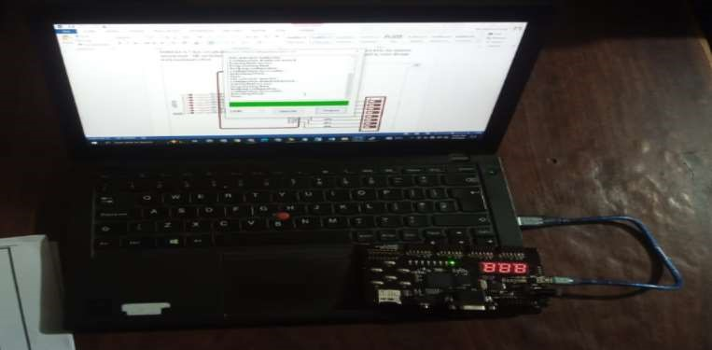

2-Implement AND/OR/XOR gate on the Kit and attach the snapshot.

**And Gate:**

**Output:**

**OR Gate:**

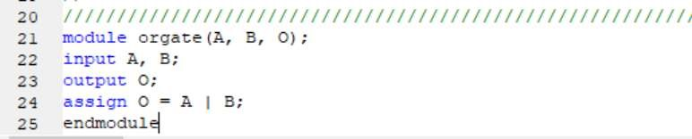

**Output:**

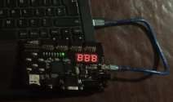

**XOR Gate:**

**Output:**



**3-Impement OR gate using NAND gate**

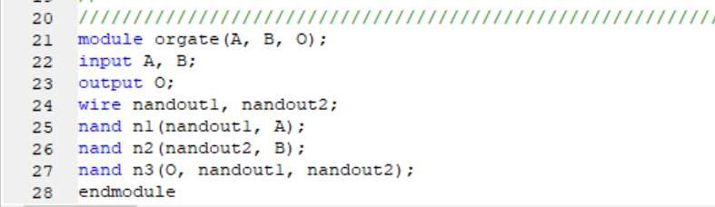

**Output Xilinx:**



1. **Implement Lab1 and Lab1 ON the Kit and attach snapshot.**

**Equation:**

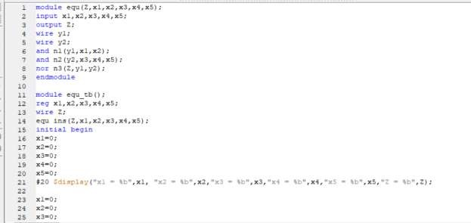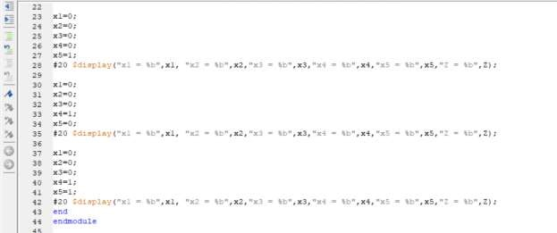

**Xilinx output:**

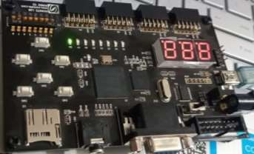

**Logic Circuit:**

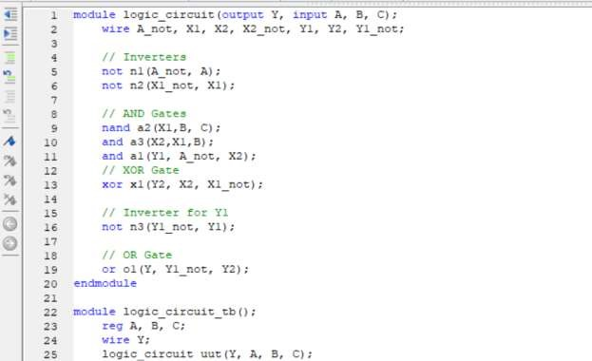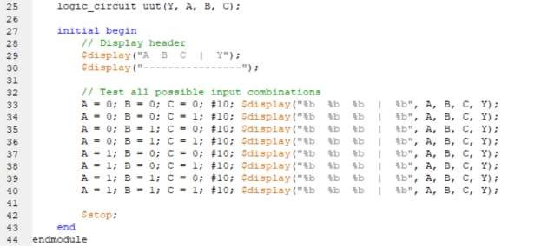

**Xilinx Output:**

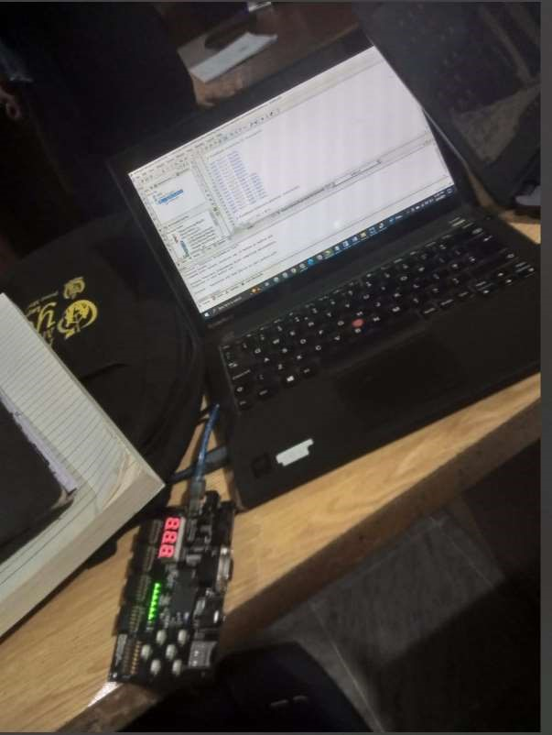

**Ripple Carry Adder:**

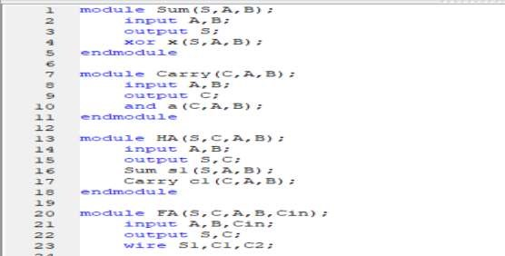

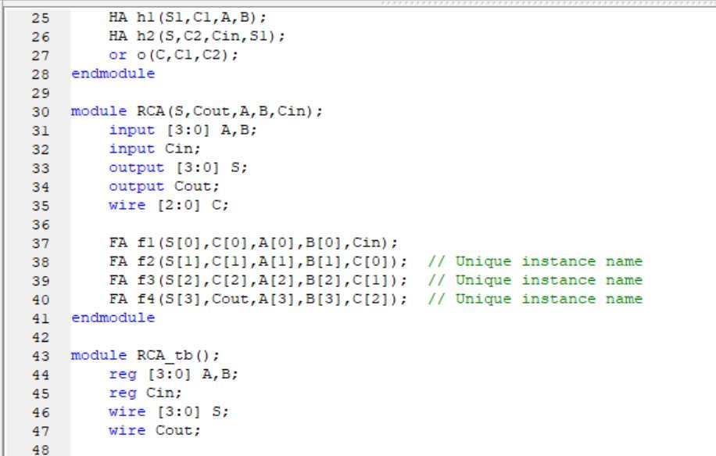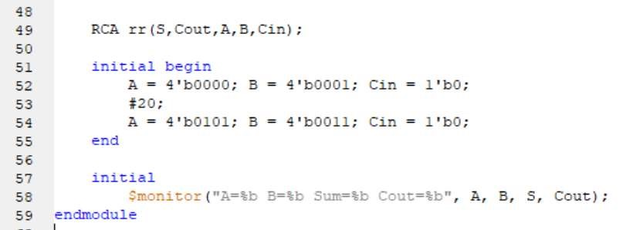

1. **Implement Full Subtractor on the board and verify the truth table**

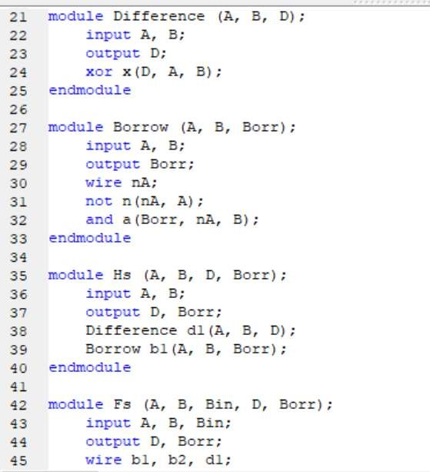

**Output Xilinx:**

